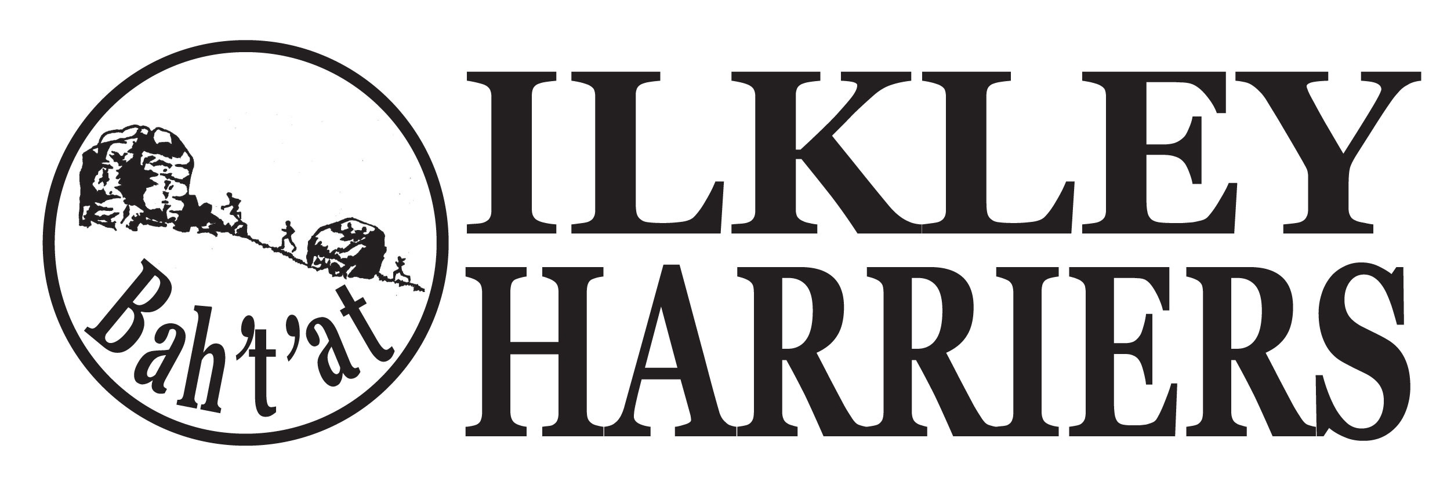
Committee Meeting

Agenda

9th January 2018
- Apologies

2. Minutes of Meeting 5th December 2017

3. Matters arising

4. Running the Club:

4.1 Harrier and Volunteer of the month

4.2 Events: Review of Christmas relays and quiz. HDSRL our race confirmation. Annual awards do organisation

4.3 Membership update and confirming review of process at February meeting

4.4 Junior update

4.5 Awards for 2017 - decisions

5. Developing the Club

5.1 Development plan

5.2 Junior facilities

6. AOB

Next meeting proposed: 8:30pm on Tuesday 6th February 2018 at ILTSC

Harrier of month nominations:
Anna Pickering for the Stoop
3xNathan Edmondson 5th at Stoop, 8th at Chevin chase
Jack Wood Myserscough 10m win, WYXC and 4th in Chevin chase (1st sprout!)

Volunteer:
2xNatalie York etc for predictor
Pete Shields for Wednesday training session

